Adding Icons in React App:

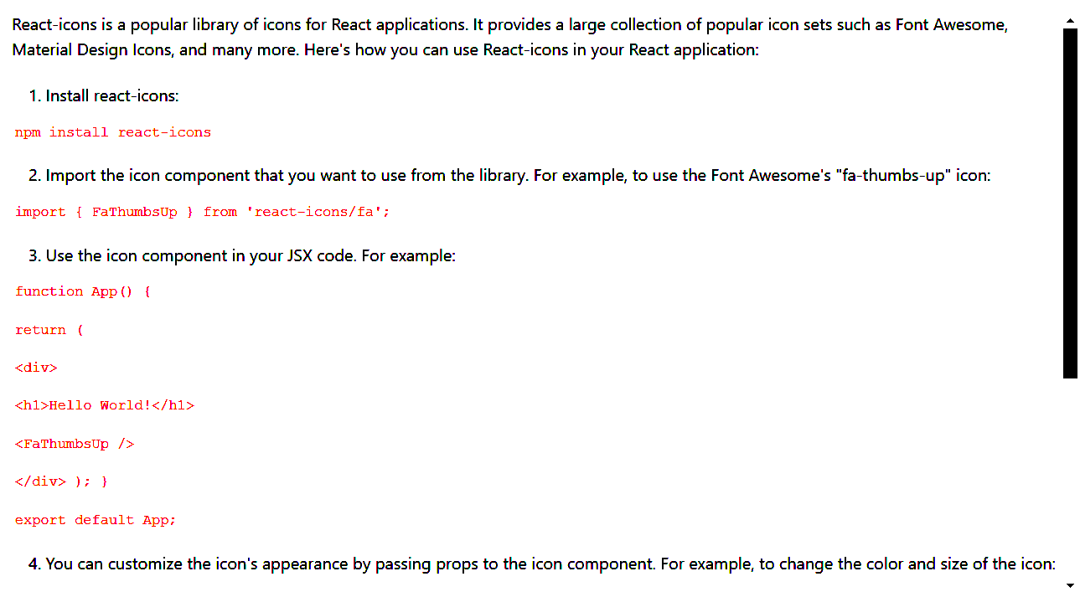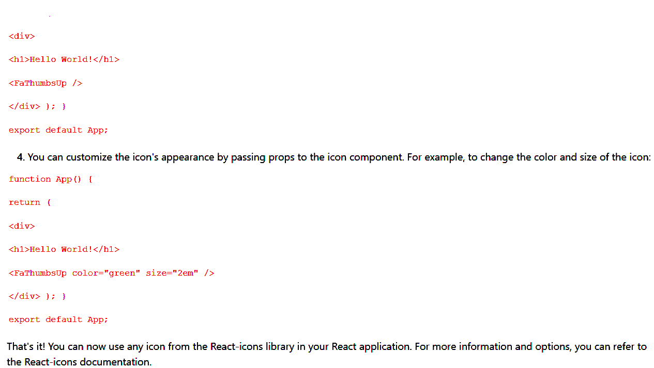

2. Adding Toast to React App:

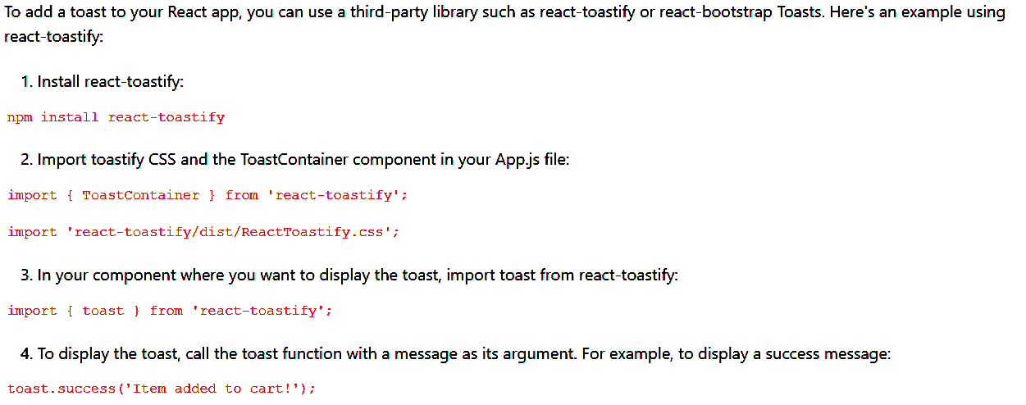

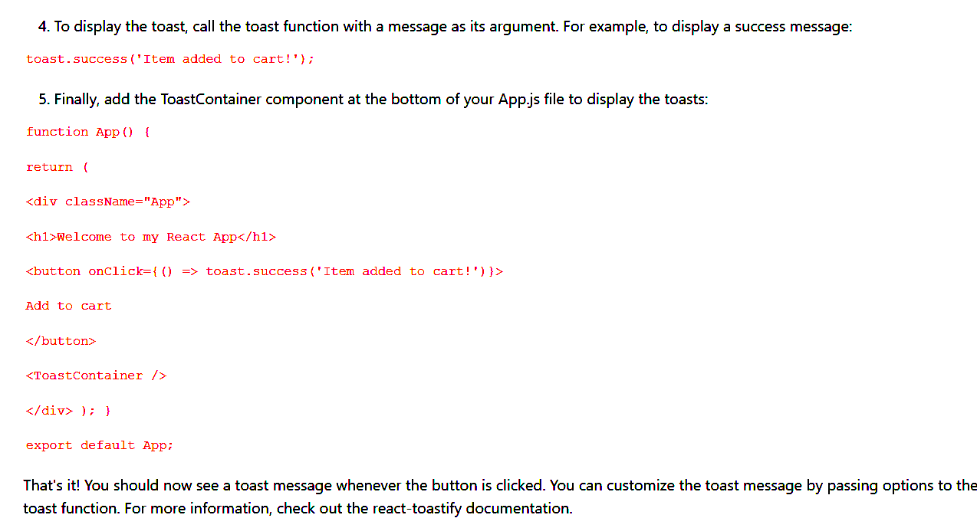

3. Onclick = (setCategory(data.title)) vs onclick (()=>setCategory(data.title))

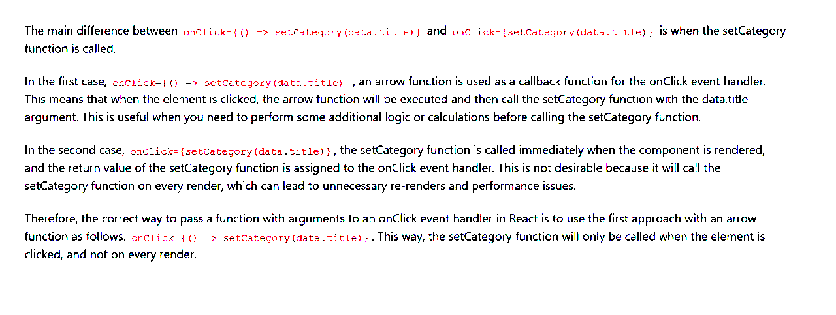

Links:  
<https://hacktoberfest.com/>

<https://gssoc.girlscript.tech/>

<https://summerofcode.withgoogle.com/>

<https://react-icons.github.io/react-icons/>  
<https://www.npmjs.com/package/react-toastify>

https://top-courses-ten.vercel.app/

***12-03-2025***

***Uselocation ->HOOK***

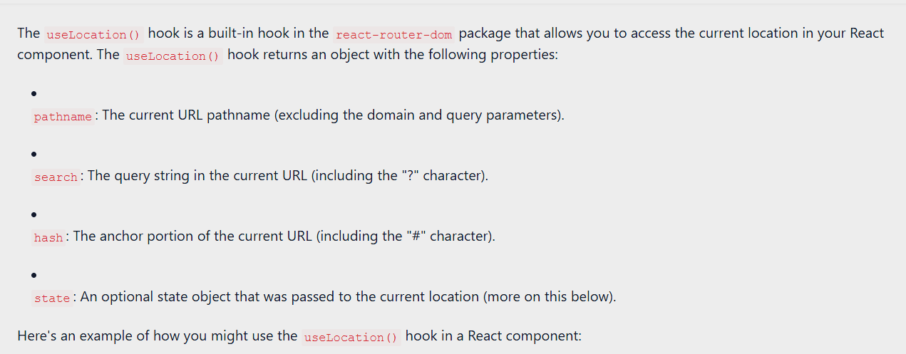

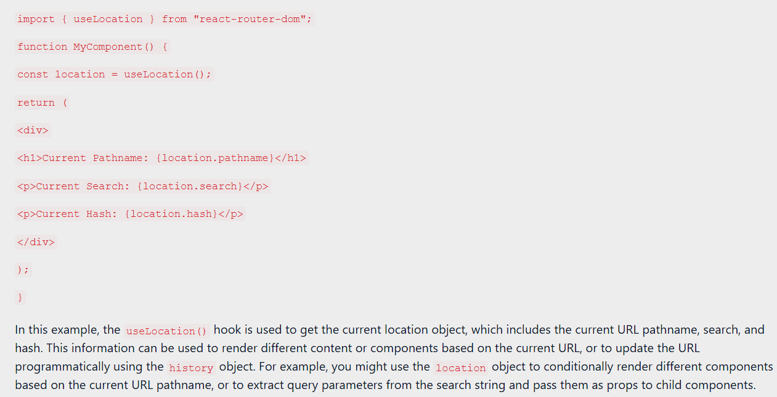

***UseSearchParams***

